**PIZZA SALES SQL QUERIES**

**A. KPI’s**

**1. Total Revenue:**

SELECTSUM(total_price)AS Total_Revenue FROM pizza_sales;

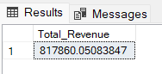

**2. Average Order Value**

SELECT(SUM(total_price)/COUNT(DISTINCT order_id))AS Avg_order_Value FROM pizza_sales

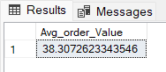

**3. Total Pizzas Sold**

SELECTSUM(quantity)AS Total_pizza_sold FROM pizza_sales

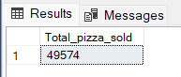

**4. Total Orders**

SELECTCOUNT(DISTINCTorder_id)AS Total_Orders FROM pizza_sales

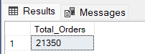

**5. Average Pizzas Per Order**

SELECTCAST(CAST(SUM(quantity)ASDECIMAL(10,2))/

CAST(COUNT(DISTINCTorder_id)ASDECIMAL(10,2))ASDECIMAL(10,2))

AS Avg_Pizzas_per_order

FROM pizza_sales

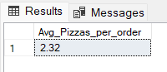

**B. Daily Trend for Total Orders**SELECTDATENAME(DW, order_date)AS order_day,COUNT(DISTINCT order_id)AS total_orders

FROM pizza_sales

GROUPBYDATENAME(DW, order_date)

***Output:***

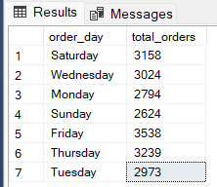

**C. Monthly Trend for Orders**

selectDATENAME(MONTH, order_date)as Month_Name,COUNT(DISTINCT order_id)as Total_Orders

from pizza_sales

GROUPBYDATENAME(MONTH, order_date)***Output***

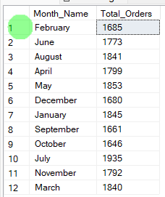

**D. % of Sales by Pizza Category**

SELECT pizza_category,CAST(SUM(total_price)ASDECIMAL(10,2))as total_revenue,

CAST(SUM(total_price)* 100 /(SELECTSUM(total_price)from pizza_sales)ASDECIMAL(10,2))AS PCT

FROM pizza_sales

GROUPBY pizza_category

***Output***

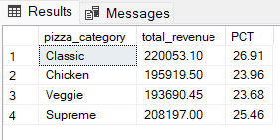

**E. % of Sales by Pizza Size**

SELECT pizza_size,CAST(SUM(total_price)ASDECIMAL(10,2))as total_revenue,

CAST(SUM(total_price)* 100 /(SELECTSUM(total_price)from pizza_sales)ASDECIMAL(10,2))AS PCT

FROM pizza_sales

GROUPBY pizza_size

ORDERBY pizza_size

***Output***

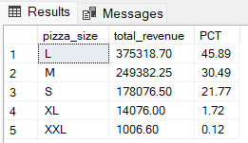

**F. Total Pizzas Sold by Pizza Category**

SELECT pizza_category,SUM(quantity)as Total_Quantity_Sold

FROM pizza_sales

WHEREMONTH(order_date)= 2

GROUPBY pizza_category

ORDERBY Total_Quantity_Sold DESC

***Output***

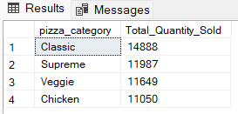

**G. Top 5 Pizzas by Revenue**

SELECTTop 5 pizza_name,SUM(total_price)AS Total_Revenue

FROM pizza_sales

GROUPBY pizza_name

ORDERBY Total_Revenue DESC

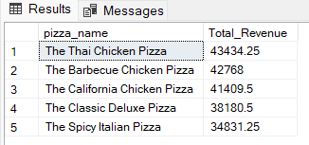

**H. Bottom 5 Pizzas by Revenue**

SELECTTop 5 pizza_name,SUM(total_price)AS Total_Revenue

FROM pizza_sales

GROUPBY pizza_name

ORDERBY Total_Revenue ASC

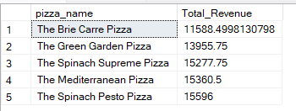

**I. Top 5 Pizzas by Quantity**

SELECTTop 5 pizza_name,SUM(quantity)AS Total_Pizza_Sold

FROM pizza_sales

GROUPBY pizza_name

ORDERBY Total_Pizza_Sold DESC

***Output***

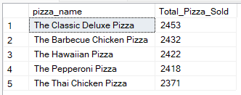

**J. Bottom5 Pizzas by Quantity**

SELECTTOP 5 pizza_name,SUM(quantity)AS Total_Pizza_Sold

FROM pizza_sales

GROUPBY pizza_name

ORDERBY Total_Pizza_Sold ASC

***Output***

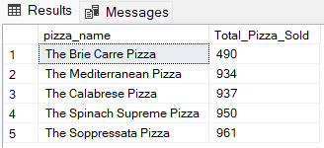

**K. Top 5 Pizzas by Total Orders**

SELECTTop 5 pizza_name,COUNT(DISTINCT order_id)AS Total_Orders

FROM pizza_sales

GROUPBY pizza_name

ORDERBY Total_Orders DESC

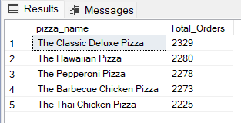

**L. Borrom 5 Pizzas by Total Orders**

SELECTTop 5 pizza_name,COUNT(DISTINCT order_id)AS Total_Orders

FROM pizza_sales

GROUPBY pizza_name

ORDERBY Total_Orders ASC

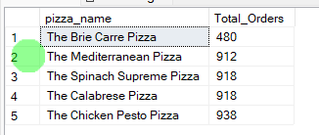

***NOTE***

If you want to apply the pizza_category or pizza_size filters to the above queries you can use WHERE clause. Follow some of below examples

SELECTTop 5 pizza_name,COUNT(DISTINCT order_id)AS Total_Orders

FROM pizza_sales

WHERE pizza_category ='Classic'

GROUPBY pizza_name

ORDERBY Total_Orders ASC